**Assignment - 3**

**A Job Ready Bootcamp in C++, DSA and IOT**

Decision Control Statements

**1. Write a program to check whether a given number is positive or non-positive.**

int main()

{

int i;

printf("Enter a number ");

scanf("%d",&i);

if(i>0)

printf("positive number");

else

printf("non positive number");

return 0;

}

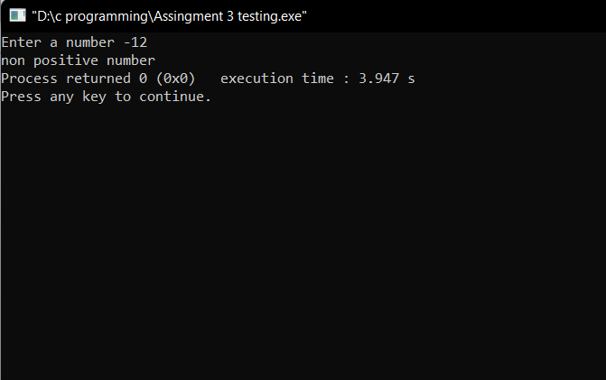

**2. Write a program to check whether a given number is divisible by 5 or not**

int main()

{

int i;

printf("Enter a number ");

scanf("%d",&i);

if(i%5==0)

printf("Divisible by 5");

else

printf("Not divisible by 5");

return 0;

}

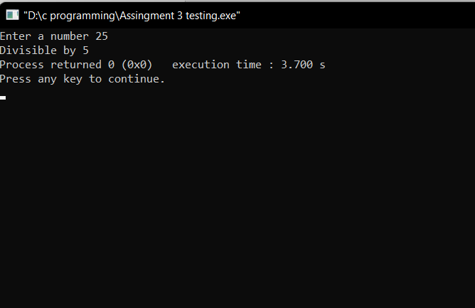

**3. Write a program to check whether a given number is an even number or an odd number.**

int main()

{

int i;

printf("Enter a number ");

scanf("%d",&i);

if(i%2==0)

printf("Even Number");

else

printf("Odd Number");

return 0;

}

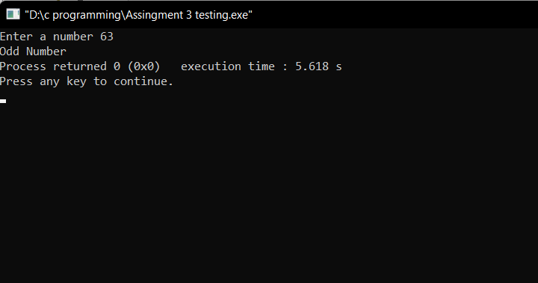

**4. Write a program to check whether a given number is an even number or an odd number without using % operator.**

int main()

{

int i;

printf("Enter a number ");

scanf("%d",&i);

if(i&1)

printf("Odd Number");

else

printf("Even Number");

return 0;

}

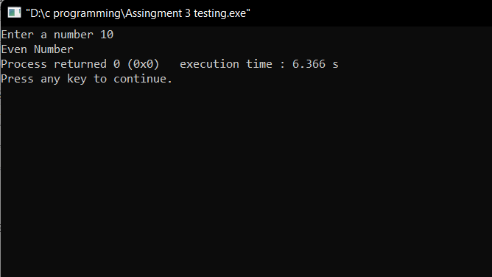

**5. Write a program to check whether a given number is a three-digit number or not.**

int main()

{

int i;

printf("Enter a number ");

scanf("%d",&i);

if(i/100!=0)

printf("Three digit Number");

else

printf("Not three Digit Number");

return 0;

}

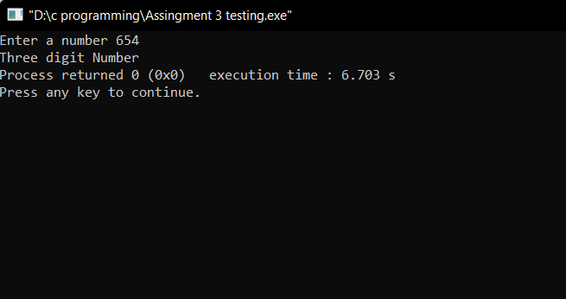

**6. Write a program to print greater between two numbers. Print one number of both are the same**.

int main()

{

int i,j;

printf("Enter Two numbers ");

scanf("%d",&i);

scanf("%d",&j);

if(i>j)

printf("%d is greater",i);

else if(i==j)

printf("%d and %d are equal",i,j);

else

printf("%d is greater",j);

return 0;

}

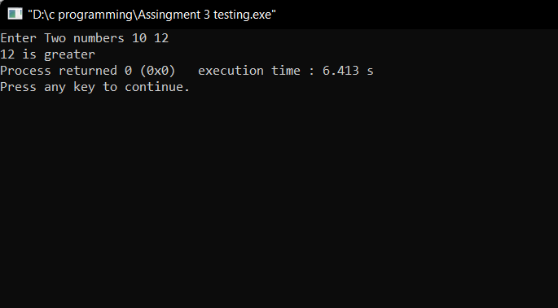

**7. Write a program to check whether roots of a given quadratic equation are real & distinct, real & equal or imaginary roots**

#include<stdio.h>

#include<math.h>

int main()

{

int a,b,c,D;

float x,y;

printf("Enter the coefficient of x^2, x and constant ");

scanf("%d %d %d",&a,&b,&c);

D=b*b-4*a*c;

if(D<0)

printf("Roots are imaginary");

if(D==0)

{

printf("Roots are equals");

x=-b/(2.0*a);

printf("\nRoots are %f",x);

}

if(D>0)

{

printf("Roots are real and distinct");

x=(-b+sqrt(D))/(2*a);

y=(-b-sqrt(D))/(2*a);

printf("\nRoots are %f , %f",x,y);

}

return 0;

}

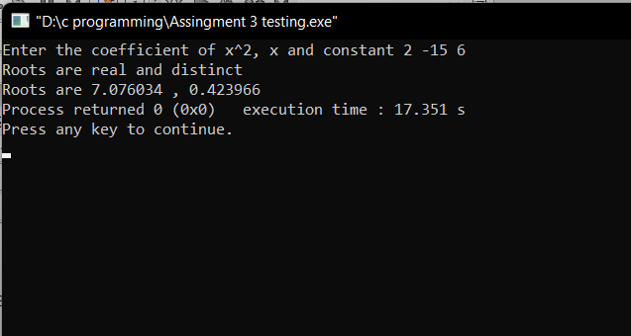

**8. Write a program to check whether a given year is a leap year or not**.

#include<stdio.h>

int main()

{

int year;

printf("Enter year");

scanf("%d",&year);

if(year%100==0)

{

if(year%400==0)

printf("leap year");

else

printf("not a leap year");

}

else

{

if(year%4==0)

printf("leap year");

else

printf("not leap year");

}

return 0;

}

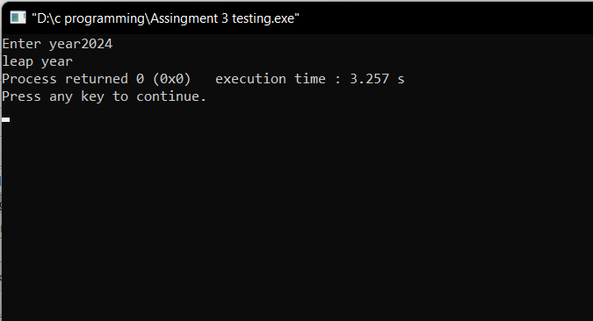

**9. Write a program to find the greatest among three given numbers. Print number once if the greatest number appears two or three times.**

#include<stdio.h>

int main()

{

int a,b,c;

printf("Enter three numbers");

scanf("%d%d%d",&a,&b,&c);

if(a>b){

if(a>c)

printf("%d is greater",a);

else

printf("%d is greater",c);

}

else

{

if(b>c)

printf("%d is greater",b);

else

printf("%d is greater",c);

}

return 0;

}

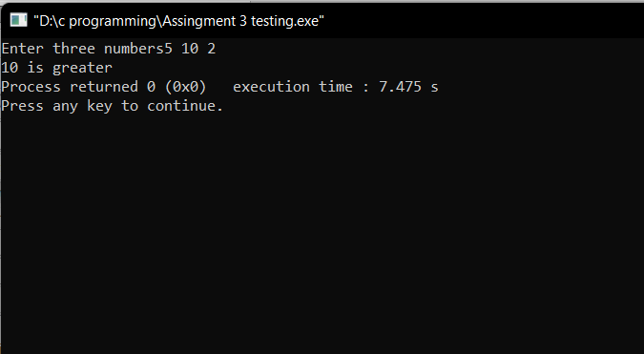

**10. Write a program which takes the cost price and selling price of a product from the user. Now calculate and print profit or loss percentage.**

#include<stdio.h>

int main()

{

double cp,sp,profit,loss;

printf("Enter cost price ");

scanf("%lf",&cp);

printf("Enter selling price ");

scanf("%lf",&sp);

profit=sp-cp;

loss=cp-sp;

if(cp>sp)

printf("loss percentage is %lf",(loss/cp)*100);

else

printf("profit percentage is %lf",(profit/cp)*100);

return 0;

}

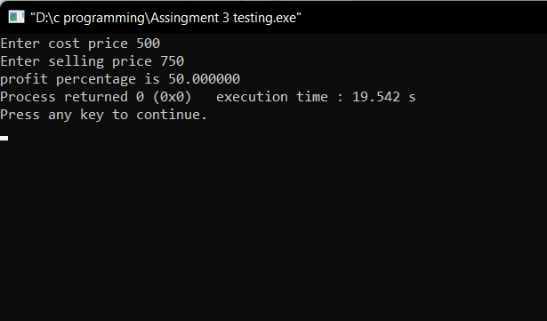

**11. Write a program to take marks of 5 subjects from the user. Assume marks are given out of 100 and passing marks is 33. Now display whether the candidate passed the examination or failed.**

#include<stdio.h>

int main()

{

int hindi,eng,math,phy,chem;

printf("Enter the student marks of 5 subjects\n\n");

printf("HINDI\t");

scanf("%d",&hindi);

printf("\nENGLISH\t");

scanf("%d",&eng);

printf("\nMATHS\t");

scanf("%d",&math);

printf("\nPHYSICS\t");

scanf("%d",&phy);

printf("\nCHEMISTRY\t");

scanf("%d",&chem);

if(hindi < 34)

printf("student fail");

else if(eng < 34)

printf("student fail");

else if(math < 34)

printf("student fail");

else if(phy < 34)

printf("student fail");

else if(chem < 34)

printf("student fail");

else

printf("student pass");

return 0;

}

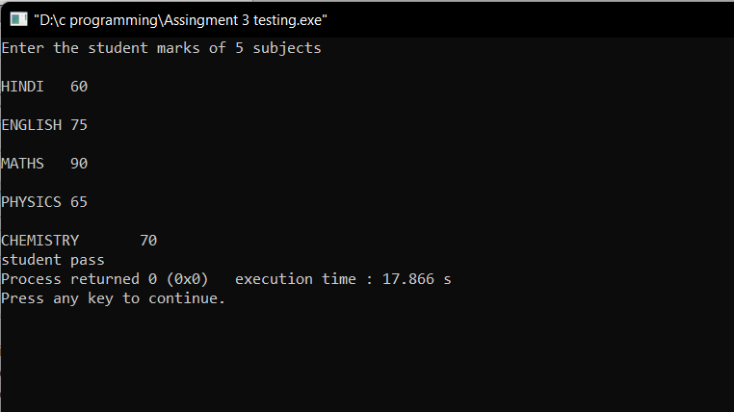

**12. Write a program to check whether a given alphabet is in uppercase or lowercase.**

#include<stdio.h>

int main()

{

char ch;

printf("Enter a alphabet ");

scanf("%c",&ch);

if(ch>=97&&ch<=122)

printf("lower case");

else if(ch>=65&&ch<=90)

printf("upper case");

else

printf("Invalid entry");

return 0;

}

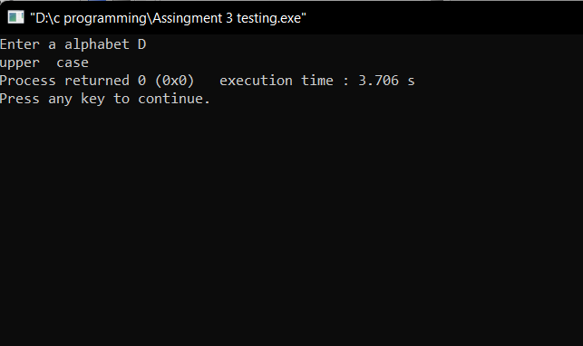

**13. Write a program to check whether a given number is divisible by 3 and divisible by 2.**

#include<stdio.h>

int main()

{

int n;

printf("Enter a number ");

scanf("%d",&n);

if(n%3==0&&n%2==0)

printf("Number is divisible by 3 and 2");

else

printf("Number is not divisible by 3 and 2");

return 0;

}

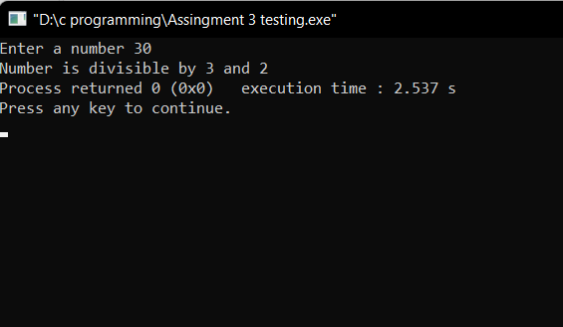

**14. Write a program to check whether a given number is divisible by 7 or divisible by 3**.

#include<stdio.h>

int main()

{

int n;

printf("Enter a number ");

scanf("%d",&n);

if(n%7==0||n%3==0)

printf("Number is divisible by 7 or 3");

else

printf("Number is not divisible by 7 or 3");

return 0;

}

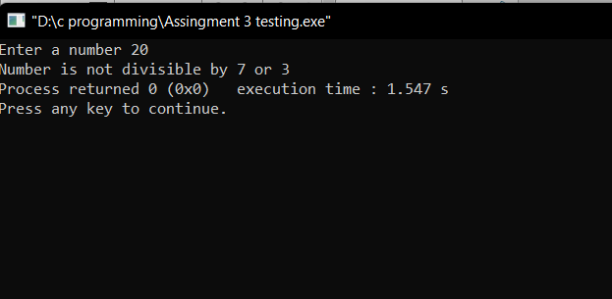

**15. Write a program to check whether a given number is positive, negative or zero.**

#include<stdio.h>

int main()

{

int n;

printf("Enter a number ");

scanf("%d",&n);

if(n>0)

printf("Number is Positive");

else if(n<0)

printf("Number is Negative");

else

printf("Number is zero");

return 0;

}

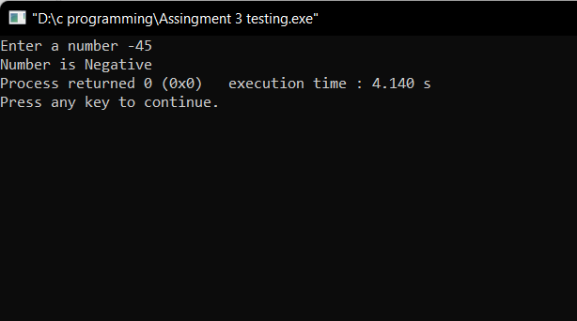

**16. Write a program to check whether a given character is an alphabet (uppercase), an alphabet (lower case), a digit or a special character.**

#include<stdio.h>

int main()

{

char ch;

printf("Enter a alphabet ");

scanf("%c",&ch);

if(ch>=97&&ch<=122)

printf("lower case");

else if(ch>=65&&ch<=90)

printf("upper case");

else

printf("Digit or special Character");

return 0;

}

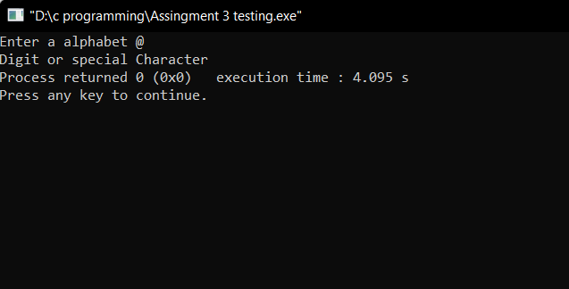

**17. Write a program which takes the length of the sides of a triangle as an input. Display whether the triangle is valid or not.**

#include<stdio.h>

int main()

{

int a,b,c;

printf("Enter the sides of Triangle ");

scanf("%d%d%d",&a,&b,&c);

if(a+b>c && a+c>b && b+c>a)

printf("Triangle is valid");

else

printf("Triangle is not valid");

return 0;

}

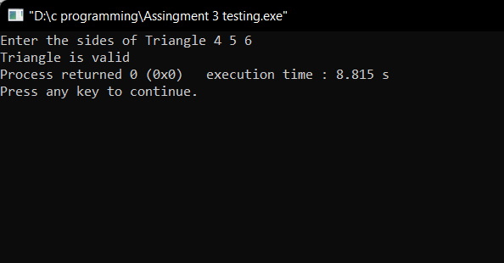

**18. Write a program which takes the month number as an input and display number of days in that month**

#include<stdio.h>

int main()

{

int n;

printf("Enter the month ");

scanf("%d",&n);

if(n==1||n==3||n==5||n==7||n==8||n==10||n==12)

printf("31 days");

else if(n==4||n==6||n==9||n==11)

printf("30 days");

else if(n==2)

printf("28/30 days");

return 0;

}

